Farm Inventory Manager
In the absence of centralized system, the datasets for farm management are handled separately, which leads to inconsistencies. Therefore, a unified system that handles multiple datasets at once in the management of livestock, number of seeds, tools, expenses, and etc.

Why is such a system required?
As the agricultural sector grows it becomes hard to keep track of records with separated datasets. A centralized system helps handle inventory and operation records efficiently, creating both a transparent and consistent method to manage inventories regardless of its size.

Who needs this?
Large crop farm owners, farm workers, farmers, people who grow crops in their garden, and farm managers.

System Requirements
- Inventory Management: Track Inventory across multiple categories including seeds, animals, tools, and farm products with CRUD operations (create, read, update, delete)
- Financial Integration: Automatically generate linked income or expense records whenever inventory entries are modified.
- Dashboard & Analytics: Provide weekly summaries of financial metrics, stock levels, an activity calendar, as well as low-stock notifications.
- Barcode System: Generate deterministic 12-digit barcodes via SHA-256 hashing and enable barcode scanning through the user’s device camera
- Offline Synchronization: Maintain offline-first architecture using a local queue, synchronizing data with the server upon network restoration.
- Reporting: Generate end export financial reports in a PDF format, allowing filters by date range and category.
- Alerts & Notifications: Evaluate custom low-stock thresholds and trigger system alerts dynamically.
- Supplier Management: Maintain records for farm suppliers including contact information, categories, and ratings
- Access User Profile: Access profile settings, subscription settings, deactivate account. Provide a bilingual user interface (Chinese / English) that can be switched seamlessly at runtime.

Fig 1.1. Functional Structure of the System
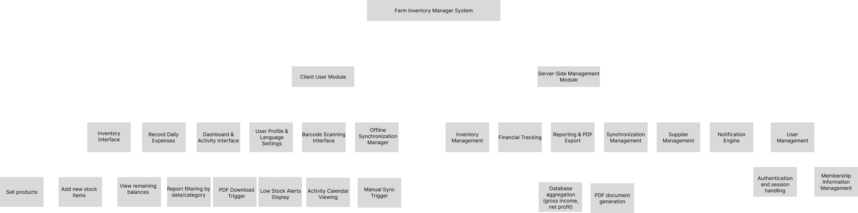

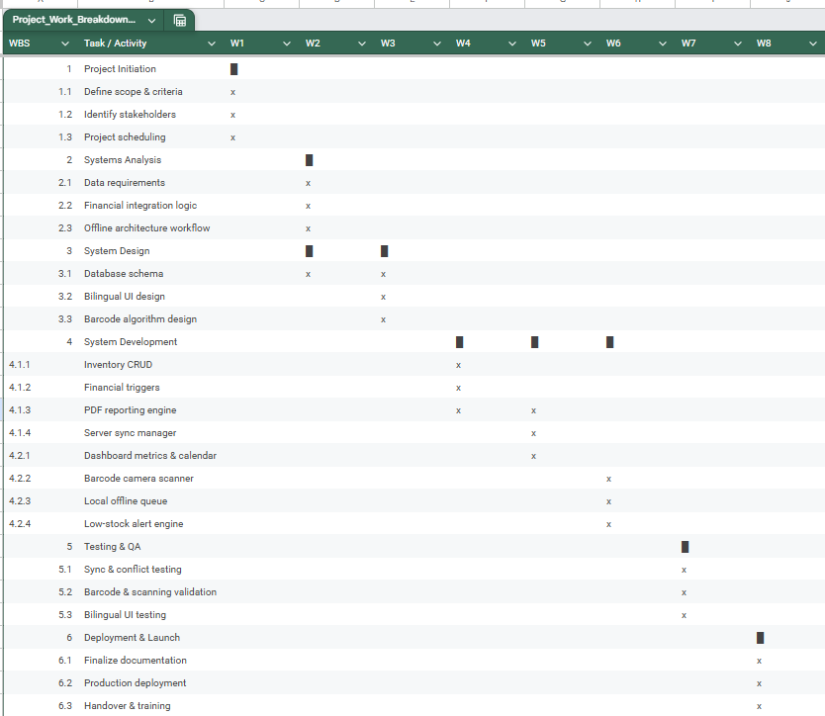
Homework 3 1. Prototyping and 2.DFD

Change Functional System Structure to Verbs- add sublevels
  - Context level DFD
  - Diagram 0
  - Diagram 1
  - Diagram 2
  - Diagram 3

Fix Diagrams:
The entity names should be the same throughout every diagram;
Place entities in corners to avoid confusion within the lines;
Make sure lines don’t intercept—if they do, have a crossover line to avoid confusion;
Do not have double headed arrows: input and output arrows should be different;
Lower level diagrams should essentially show the upper level function just in a detailed manner, meaning the data, entities and etc. should all be the same. Just subfunctions shown, data flows (arrows) separated into the subfunctions and data stores. The entities interacting with it should be shown. NO FARMER/MANAGER inside one entity. Entities and data flows should be atomic. They can not change/ have different names at the lower level diagrams.
Refer to the slides.

2. Use Case Diagram FIX!
3. Activity Diagram REFER TO PICTURE OF THE BOARD
Have parallel activity

Fixes: DFD’s Context level DFD must have as many output/input arrows as Level 0 Diagram. For level 0 add some inputs/outputs that have been missing (check level 1 for confirmation) Level 0 DFD refer to board picture taken for reference – if several inputs/outputs by 1 entity/process name it 1,2,3… (in a single arrow) (and you may show the name of the activity when you hover over the numbers) to be able to fit them in the lvl 0 diagram. And other level diagrams. Prime example is farm owner to 4.0 (it has 2 inputs 1 output but on level 0 it looks like 1 because revenue entry & margin query is written in 1 line. Check all DFD’s, and fix this error where needed.

Hw:
Sequence diagram
Class diagram

